



# Instructions

This document is required to review the proposed solution. It is not the final design and the information is expected to be refined in the design phase. The information in this document will provide Oracle insight into the proposed solution.

# Document Change Record

|  |  |  |  |
| --- | --- | --- | --- |
| Date | Version | Author  Include Title, email address and contact phone number | Comments |
| 23-04-2019 | 1 | Marco Aurélio Prado <[marco.vidoca@enext.com.br](mailto:marco.vidoca@enext.com.br), +55 11 98140-5682> Lucas Ribeiro <[lucas.ribeiro@enext.com.br](mailto:lucas.ribeiro@enext.com.br), +55 17 98185-3911>  Rogério Santos <[rogerio.santos@enext.com.br](mailto:rogerio.santos@enext.com.br), +55 11 98207-8850> |  |
| 14-10-2019 | 1.1 | Marco Aurélio Prado <[marco.vidoca@enext.com.br](mailto:marco.vidoca@enext.com.br), +55 11 98140-5682>  Rogério Santos <[rogerio.santos@enext.com.br](mailto:rogerio.santos@enext.com.br), +55 11 98207-8850> |  |
| 05-12-2019 | 1.2 | Rogério Santos <[rogerio.santos@enext.com.br](mailto:rogerio.santos@enext.com.br), +55 11 98207-8850> |  |

# Solution Overview

## Business Value of Solution

This solution is intended to be an Oracle Commerce Cloud Marketplace Service. It is a Custom Payment Gateway (CPG) that can integrate a payment provider (PP) and/or an anti-fraud provider (AFP) with an Oracle Commerce Cloud (OCC) store. The main purpose of this solution is to implement a payment system on an OCC store that uses either the Braspag Payment Provider and/or the Braspag Anti-Fraud Provider. The solution was designed to deal with e-commerce stores focused on brazilian market.  
  
The architecture joins the security of an anti-fraud provider (for the credit card transactions) and multiples payment types (credit card, cash etc) of a payment provider.

Besides that, our solution will update OCC when the transaction status changes. On the anti-fraud provider side, when the credit card analysis is complete, the system will automatically capture or refund the payment. In cash payment case, when the customer pays or the ticket expire, the order status will be updated at OCC too.

This solution counts with a credit card tokenization, which the customers can save their credit cards safely. If the credit card tokenization feature is enabled, for each credit card transaction the system will save a token associated with the credit card and with that token the e-commerce client can make a future purchase without inserting his credit card again.

## Features

* Merchant/OCC view:
  + Use Braspag Payment Provider;
  + Use Braspag Payment Provider and other Anti Fraud Provider (including the Braspag Anti Fraud Provider);
  + Use Braspag Anti-Fraud Provider and other Payment Provider (including the Braspag Payment Provider);
  + Edit payment configurations through the payment gateway settings on OCC;
  + Automatic order status update;
* E-commerce client view:
  + Payments with credit card;
  + Payments with cash (brazilian payment method);
  + Save credit card for future purchases.

## Use cases

The ecommerce user has two types of use cases:

1. Simple order

The user add some products to his cart and go to the checkout page, then it chooses the payment method and confirm the payment. The system will process the order and return a payment status.

[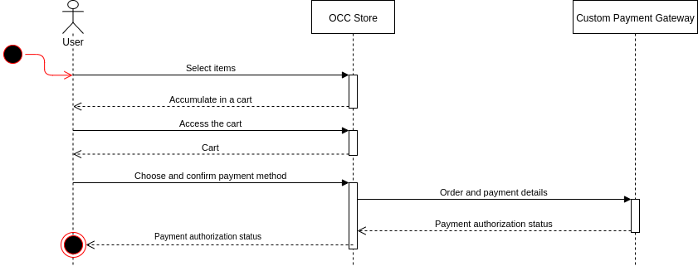](https://www.draw.io/?page-id=L-aktZlDIiXkbdKfOPhn&scale=auto#G19AwAtAWyk_yiNuqX3UhECAkIhssaLsmG)

Sequence diagram of the simple order using just transaction authorization.

Ps: In the simple order, the merchant can choose which flow he will uses for credit card transactions , just authorize and capture these transactions later manually on the payment provider admin panel or if he wants use the automatic capture and automatic void provided by your payment provider if it supports this service.

2. Ordering and save card

The user can save his credit card for future purchases. The flow is the same at the Simple order, but it declares the intention to save the credit card to future purchases.

[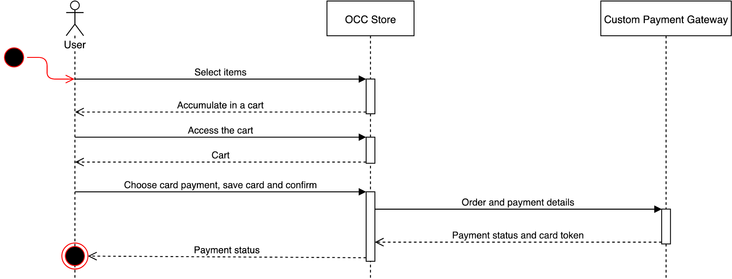](https://www.draw.io/?page-id=lrnVexJ6Tk84Y9inqfV-&scale=auto#G19AwAtAWyk_yiNuqX3UhECAkIhssaLsmG)

Sequence diagram of ordering and saving the card.

## Oracle Cloud Services used in the solution

|  |
| --- |
| Oracle Public Cloud Service |
| Oracle SaaS Services  **Oracle Commerce Cloud – Describe how your solution will be integrating with OCC, including data model extensions, API and Webhook calls, UI and widget creation, server-side extensions, and other OCC requirements.**   * OCC Server Side Extensions * OCC API:   + /ccadmin/{{API_VERSION}}/login     - Used to get the credentials to use the API.   + /ccadmin/{{API_VERSION}}/sitesettings/{{EXTENSION_NAME}}     - Used to get the properties of the extension.   + /ccadmin/{{API_VERSION}}/orders/{{ORDER_ID}}     - Used to get order details and to update order payment status.   + /ccadmin/{{API_VERSION}}/profiles/{{SHOPPER_ID}}     - Used to update saved cards in shopper profile info. * OCC Widgets to create the checkout layout * OCC Webhook of generic payments * OCC Webhook of card payments |

## Third party Cloud Services and On-Premise applications used in the solution

**Braspag API:** Responsible to be payment provider and the anti fraud provider. In differents integrations, the platform provides the functions to register payments, control it and realize card analyzes. Braspag is not essentially the anti fraud provider, but has an integration with Cybersource, which really makes the analyses.

**Payment Provider API:** Our solution can use a payment provider other than Braspag (in case the client contracts just the Braspag anti-fraud), so our system will communicate with APIs of others payment providers.

**Anti-Fraud Provider API:** Our solution can use a anti fraud provider other than Braspag (in case the client contracts just the Braspag payment provider), so our system will communicate with APIs of others anti-fraud providers.

## Logical Architecture Overview for the Solution

The CPG is developed in NodeJS and will be hosted in a Server-side extension. It communicates with:

* OCC: Through the generic payment or the credit card payment webhooks all payments will be processed calling our nodejs application;
* Payment Provider API: At every transaction, our nodejs application will call the Payment Provider API endpoint corresponding to the payment method choiced by the ecommerce client;
* Anti Fraud Provider: At every transaction made with a credit card, the corresponding endpoints will be called to the anti fraud provider API submitting the credit card transaction to analysis;

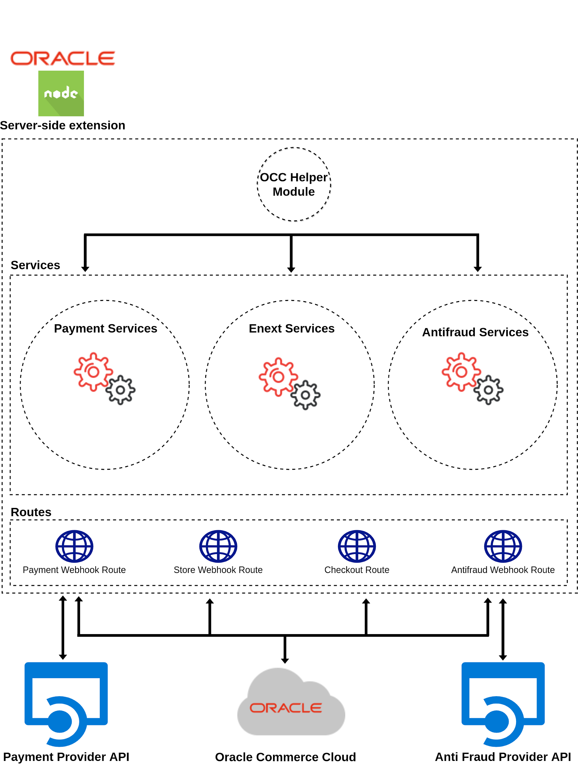

Logical architecture

## Process Flows

Custom Payment Gateway can be used in different ways: just like a payment provider or like a payment provider and anti fraud provider. In both ways, the solution has three routes to receive notifications from webhooks informing the changes in the payment status and/or the analysis of the antifraud and orders confirmed. These webhooks will update all components (OCC Store and Payment Provider) according the status notification that receives.

A common functionality is the feature to save cards. When the payment is by credit card, the user can specify that he wants to save his credit card to use it in futures transactions (if the payment provider supports). Doing this, the payment provider will return a token to OCC Store storage into shopper profile properties. In this case, does not matter the processing, the token will be returned and saved, using anti fraud provider or not.

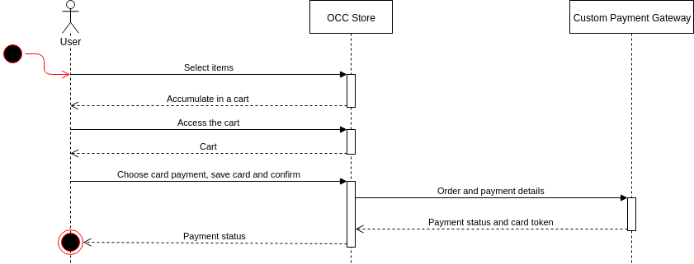

User pays and saves his credit card.

1. Payment without fraud analysis

In this section, CPG is used just like a payment provider.

When the payment type is credit card or cash, the user does all the steps to fill his cart, then in the checkout page after he chooses the payment method and confirm, the OCC Store sends all data about the order to our Custom Payment Gateway. The Payment Gateway is responsible to process the data and send to the payment provider of the store. The payment provider process the payment details and returns a response of success or fail, the payment provider response will be presented to the user.

1.1 Credit card payment

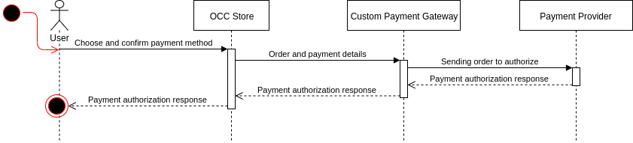

Credit card payment without fraud analysis.

1.2. Cash payment

The data flow is the same of the previous way, but instead of return a payment response, it will return the URL of a ticket. This URL is the order bill to the user pay.

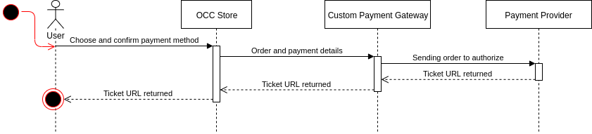

Cash payment.

Notes:

If the merchant doesn’t uses fraud analysis he can choose which flow he will uses for credit card transactions, just authorize and capture these transactions later manually on the payment provider admin panel or if he wants use the automatic capture and automatic void provided by your payment provider if it supports this service. For cash payments, the custom gateway should be waits a notification sent by issue bank of the bill to payment provider confirming shopper payment and after this, the payment provider will sends a notification to custom gateway informing changes on transaction status.

2. Payment with fraud analysis

In this section, it is presented the solution like a payment provider and anti fraud provider.

When the shopper is finishing the order in checkout page, the CPG preauthorize the order for process that in background.

Payments with credit card and fraud analysis are authorized when they ones are processed in background. In this case, the order submit webhook sends a notification to CPG informing which the shopper confirmed the order successfully. The payment can be follow two ways: first analyze, then authorize (AnAu) or first authorize, then analyse (AuAn).

* **Pre Authorize**: The CPG pre authorize order to process one in background when receives a notification from occ order submit webhook.
* **Process authorization and analysis integrated**: The CPG process the payment authorization and fraud analysis with integrated providers (Braspag Payment Provider + Braspag Antifraud Gateway - Cybersource).
* **Process authorization and analysis (default flow)**: The CPG process the payment authorization and fraud analysis with different providers.
* **Analysis Status**: The CPG treat the case responses of the antifraud provider.
  + **Accept**: The AF analysis result is ok to that payment, and the transaction continues.
  + **Review**: When the AF analysis is review, the merchant needs to do a manual analysis. The review analysis is made in the anti fraud provider, after the analysis the AF will notify the CPG, and the actions for this notification will be explained later.
  + **Reject**: If the AF analysis is reject, the transaction is canceled.

2.1. Pre Authorize Order

When the merchant use fraud analysis and transaction payment type is credit card, OCC credit qcard webhook calls CPG and it’s returns a mock response to authorize order. This feature has been added because timeout request should be occurred when the shopper confirm order.

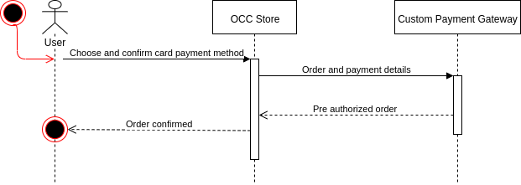

2.2 Process authorization and analysis

In the integrated flow, the payment provider Braspag has a native integration with Cybersource, the CPG uses this through the Braspag antifraud gateway service. Currently, the antifraud gateway is only integrated with Cybersource. The differential of the integration is which with a unique request to payment provider, the transaction is authorized and analyzed, making needless of different requests to authorize and analyze transaction.

In default flow, the CPG make a request to authorize and another to analyse payment data.

These integrations can be used with two ways: AnAu (Analyse then Authorize) and AuAn (Authorize then Analyse).

2.2.1 Process authorization and analysis - AuAn flow (Authorize then Analyse)

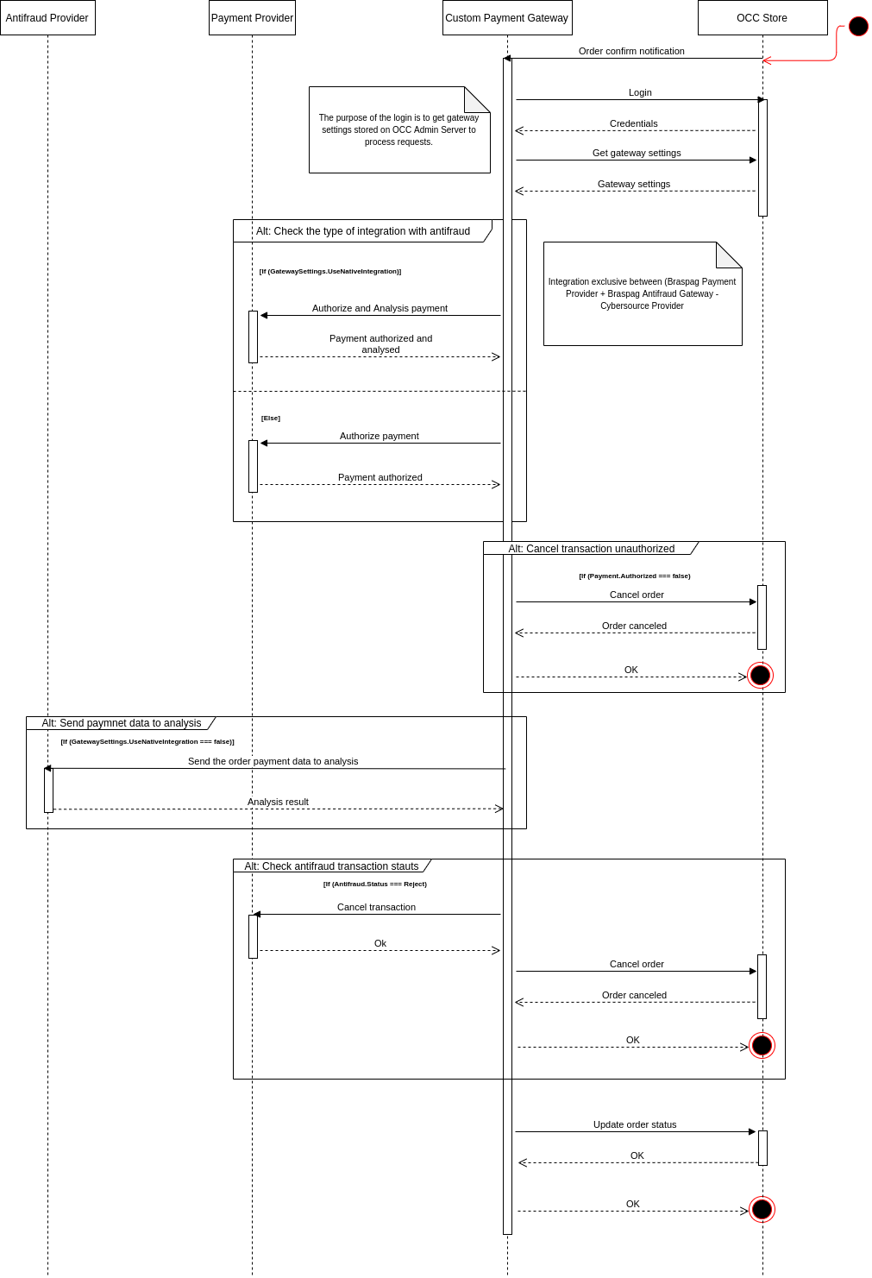

2.2.2 Process authorization and analysis - AnAu flow (Analyse then Authorize)

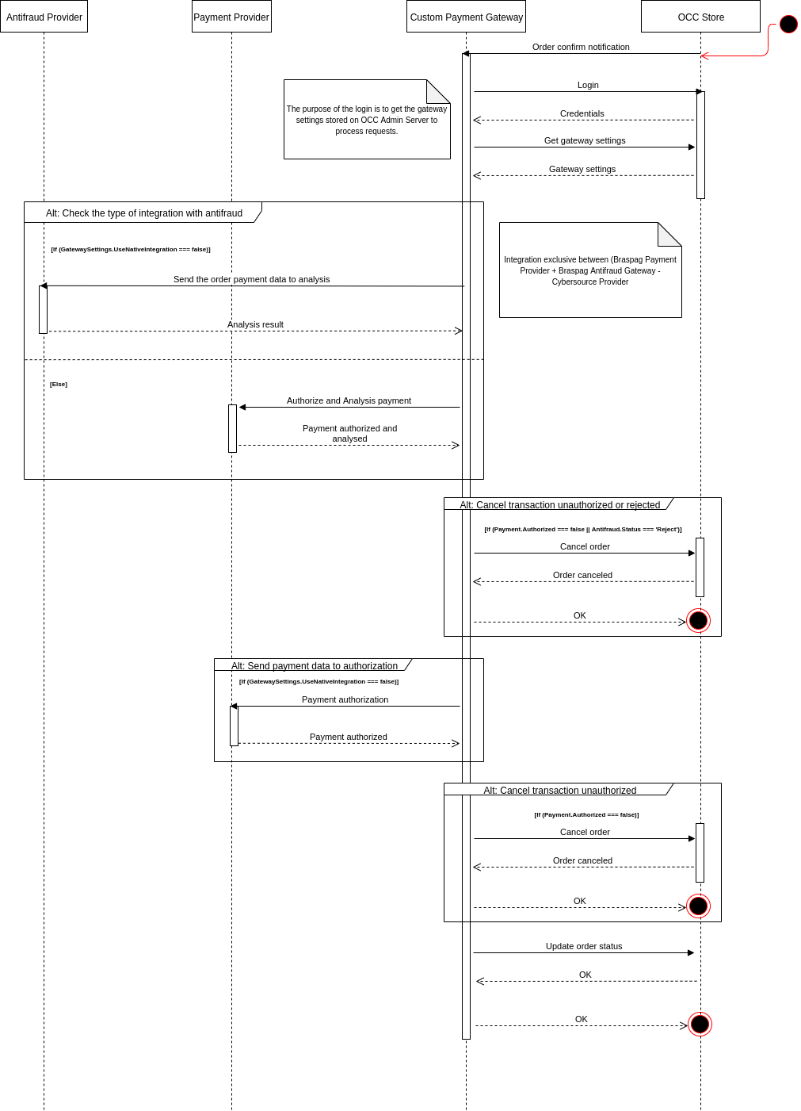

3. Custom Payment Gateway - Webhooks

The CPG has three routes which can be used like webhooks, antifraud, payment and store. These routes receives respectively notifications when fraud analysis with review status are resolved, when transactions in payment provider has status changes and when the shopper confirm order in checkout page.

3.1 Payment Webhook

The payment webhook is used in two ways: For transactions with fraud analysis or transactions without fraud analysis.

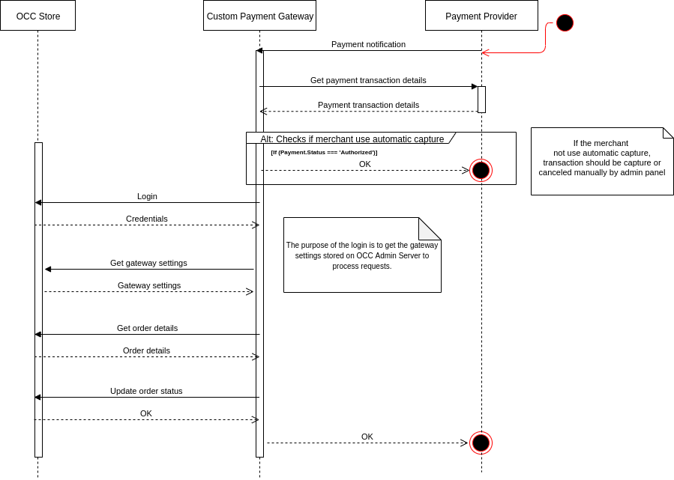

Payment webhook settles order without fraud analysis

Note: This flow is used for settles credit card payments without fraud analysis and cash payments on occ after Braspag process the notification sent by issue bank of bill confirming the shopper payment and after this, the Braspag payment webhook sends a notification informing changes at transaction status.

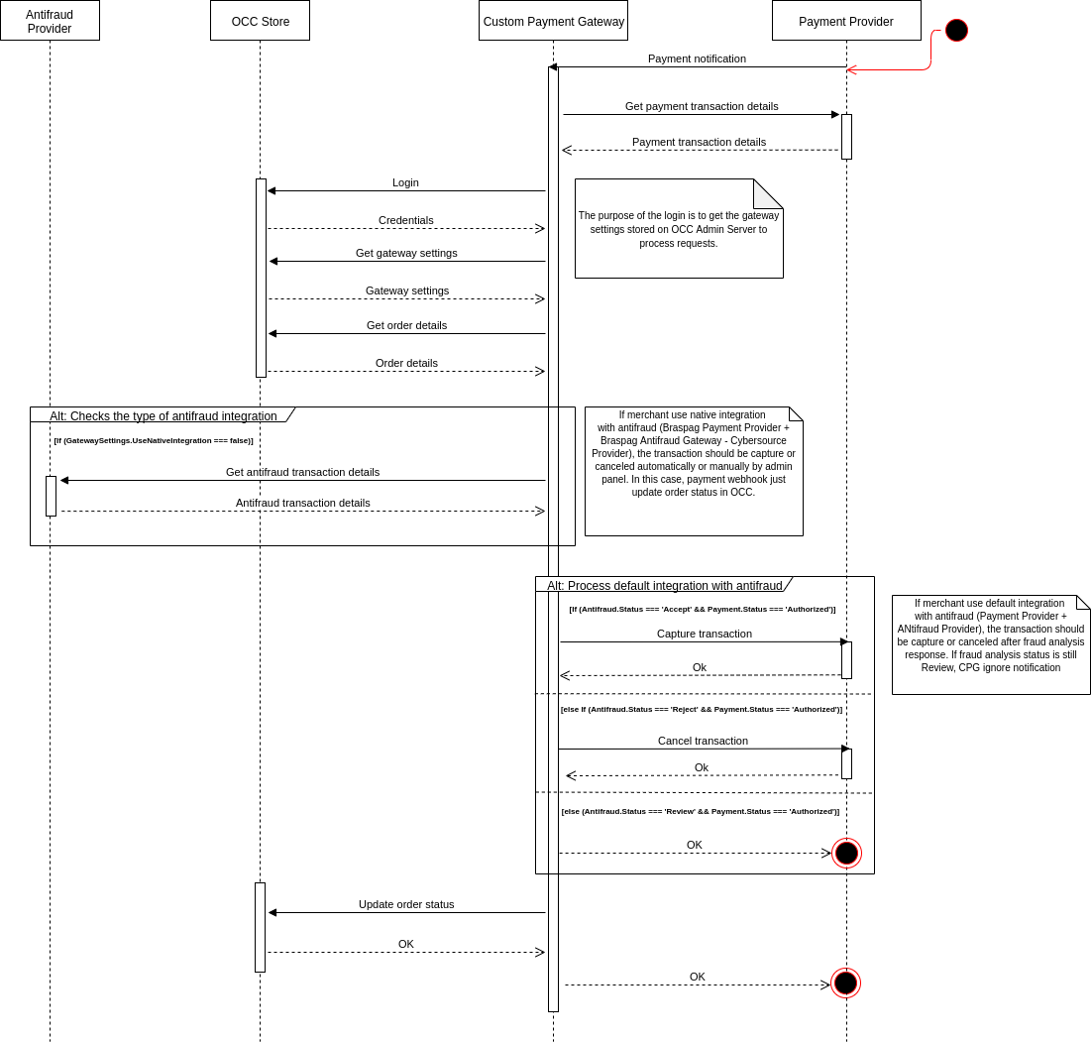

Payment webhook process transaction with fraud analysis

3.2. Antifraud Webhook

The antifraud webhook receive notifications after an operator make a decision about fraud analysis with review status.

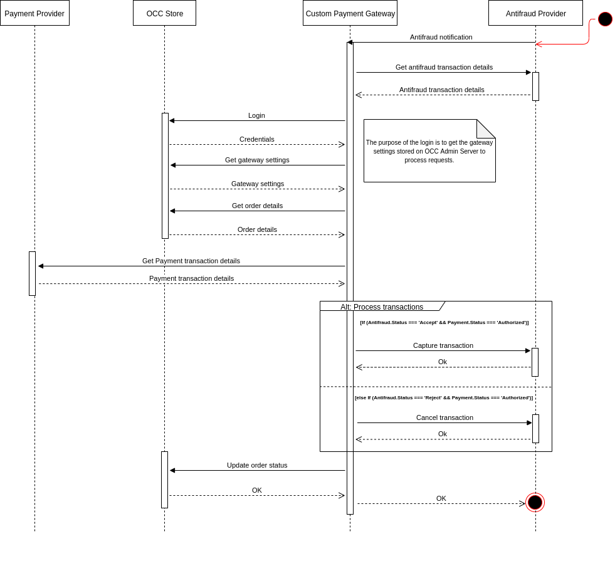

AF webhook process order after manual analysis result.

33. Store webhook

The store webhook listen all notifications which occ order submit webhook sends after an order be confirmed by shopper in checkout page. This route also is used to process orders with credit card payment type in background.

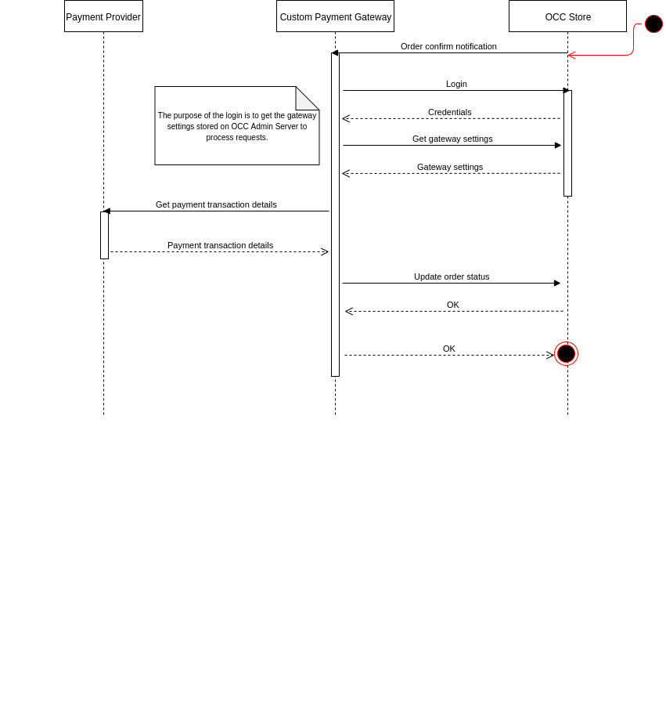

Store webhook process transaction without fraud analysis

Note: Transactions with fraud analysis also uses store route, this is demonstrated at section 2.2.

# Oracle Cloud Application Services (SaaS) Integration Overview

### Standard Objects

|  |  |  |  |  |  |
| --- | --- | --- | --- | --- | --- |
| SaaS Service | Name of Standard Object | Custom Fields / Flexfields | Operations performed on this standard object via Service Interfaces | Read/ Write | Frequency – Real time/batch |
| REST API | Order | - | GET/UPDATE | Read & Write | Less than 5 calls to each transaction |
| REST API | Profile | - | UPDATE | Write | 1 call if the shopper want save credit card |
| REST API | Site Settings | - | GET | Read | 1 call to each notification received by custom gateway |

# Acronyms, Abbreviations and Terms

* OCC: Oracle Commerce Cloud
* CPG: Custom Payment Gateway
* PP: Payment Provider
* AFP: Anti Fraud Provider
* AnAu: Analyze and then authorize
* AuAn: Authorize and then analyze

# Additional Information

Braspag API documentation: <https://braspag.github.io/>